New York Street Bridge Project
Update #3, February 2024 (Open House Public Information Meeting)

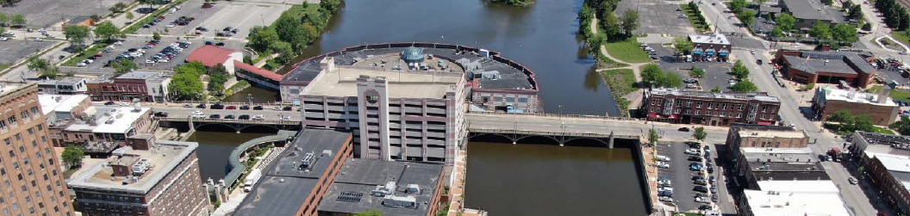

Dear Aurora Downtown Property and Business Owners,

The City of Aurora, in conjunction with their consultant Alfred Benesch & Company (Benesch), is continuing work on the Phase I engineering study for the repair of the New York Street bridge over the Fox River.

This is a reminder that the City will be hosting a meeting on Wednesday February 21, 2024, between 4:30pm & 6:30pm, on the 5th Floor Conference Room in City Hall (44 E Downer Place, Aurora, IL). The meeting will be an Open House Public Information Meeting that is open to the general public. There is no formal presentation, and you can attend at any point during the 2-hour window.

The construction of the bridge is still tentatively scheduled for 2026 at the earliest, subject to Illinois Department of Transportation (IDOT) approvals and funding availability.

The website (link below) has been updated with the exhibits that will be on display.
https://www.aurora-il.org/2570/New-York-Street-Bridge-Project

If you cannot attend the February 21st meeting and want more details on the project at this time, please contact Tina de Chaud at Aurora Downtown or Tim Weidner with the City at 630-256-3202 or WeidnerT@aurora.il.us (email preferred).

Thank you,

Tina de Chaud, Email: Tina@auroradowntown.org

